**St. Francis Institute of Technology**

**Department of Computer Engineering**

**Academic Year: 2021-2022 Semester: VIII**

**Subject: Cloud Computing Lab Class / Branch / Division: BE/CMPN/A**

Name :-Rebecca Dias Roll Number:18

**Experiment No: 01**

**Aim:** Installation of Operating System on Virtual Machine.

**Theory:**

1. Explain virtualization and types of Virtualization.

Virtualization is the "creation of a virtual (rather than actual) version of something, such as a server, a desktop, a storage device, an operating system or network resources".

In other words, Virtualization is a technique, which allows to share a single physical instance of a resource or an application among multiple customers and organizations. It does by assigning a logical name to a physical storage and providing a pointer to that physical resource when demanded.

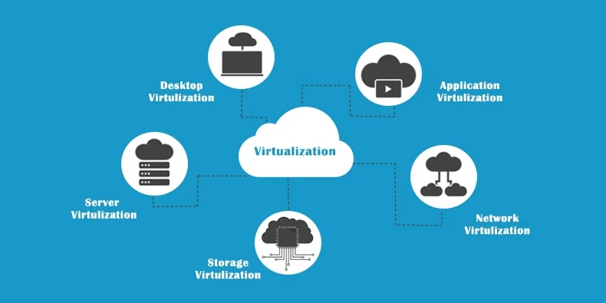

Fig 1: Types of Virtualization

Types of Virtualization:

1. *Hardware Virtualization.*

When the virtual machine software or virtual machine manager (VMM) is directly installed on the hardware system is known as hardware virtualization.

The main job of hypervisor is to control and monitoring the processor, memory and other hardware resources.

1. *Operating system Virtualization.*

When the virtual machine software or virtual machine manager (VMM) is installed on the Host operating system instead of directly on the hardware system is known as operating system virtualization.

1. *Server Virtualization.*

When the virtual machine software or virtual machine manager (VMM) is directly installed on the Server system is known as server virtualization.

1. *Storage Virtualization.*

Storage virtualization is the process of grouping the physical storage from multiple network storage devices so that it looks like a single storage device.

Storage virtualization is also implemented by using software applications.

1. Explain Hypervisor in detail (Host and Bare Metal Hypervisor)

A hypervisor is a crucial piece of software that makes virtualization possible. It abstracts guest machines and the operating system they run on, from the actual hardware.

Hypervisors create a virtualization layer that separates CPU / Processors, RAM and other physical resources from the virtual machines you create.

The machine we install a hypervisor on is called a host machine, versus guest virtual machines that run on top of them.

* **Type 1 Hypervisor** (also called bare metal or native)
* **Type 2 Hypervisor** (also known as hosted hypervisors)

*Type 1 Hypervisor*

A bare-metal hypervisor (Type 1) is a layer of software we install directly on top of a physical server and its underlying hardware.

There is no software or any operating system in between, hence the name bare-metal hypervisor. A Type 1 hypervisor is proven in providing excellent performance and stability since it does not run inside Windows or any other operating system.Type 1 hypervisors are an OS themselves, a very basic one on top of which you can run virtual machines. The physical machine the hypervisor is running on serves virtualization purposes only.

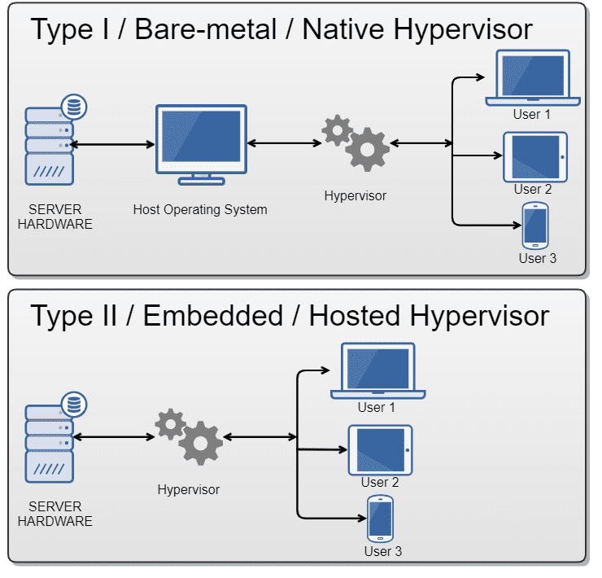

Fig 2: Types of Hypervisors

*Type 2 Hypervisor*

This type of hypervisor runs inside of an operating system of a physical host machine. This is why we call type 2 hypervisors – hosted hypervisors. As opposed to type 1 hypervisors that run directly on the hardware, hosted hypervisors have one software layer underneath. In this case we have:

* A physical machine.
* An operating system installed on the hardware (Windows, Linux, macOS).
* A type 2 hypervisor software within that operating system.
* The actual instances of guest virtual machines.

1. What is a Virtual Box?

Oracle VM Virtual Box (formerly Sun VirtualBox, Sun xVM VirtualBox and Innotek VirtualBox) is a type-2 hypervisor for x86 virtualization developed by Oracle Corporation.

VirtualBox may be installed on Microsoft Windows, macOS, Linux, Solaris and OpenSolaris. There are also ports to FreeBSD and Genode. It supports the creation and management of guest virtual machines running Windows, Linux, BSD, OS/2, Solaris, Haiku, and OSx86, as well as limited virtualization of macOS guests on Apple hardware.For some guest operating systems, a "Guest Additions" package of device drivers and system applications is available, which typically improves performance, especially that of graphics, and allows changing the resolution of the guest OS automatically when the window of the virtual machine on the host OS is resized.

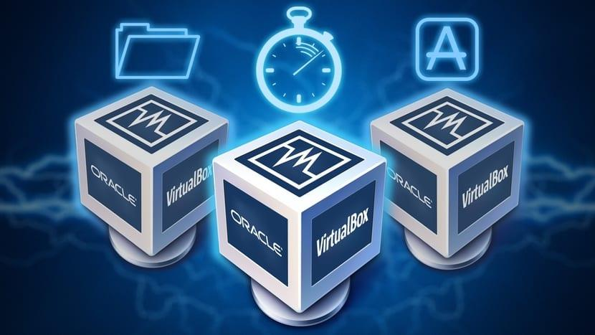

Fig 3: Virtual Box

1. Role of Virtualization in cloud computing

Virtualization software allows multiple operating systems and applications to run on the same server at the same time, and, as a result, lowers costs and increases efficiency of a company’s existing hardware. It’s a fundamental technology that powers cloud computing.

Virtualization thus emulates hardware. Cloud computing is a service that results from that manipulation and is an external service. Cloud computing almost always assumes virtualization of certain resources (storage or data) that will be then delivered to the customer on-demand.

The public cloud environment is one in which all of the virtualization is housed somewhere else, and a vendor provides the service to clients on a fee basis. In the public cloud, there are “co-tenants” in the same cloud, and clients pay for the specific services they use, as they use them.

1. Explain XEN, ESXi, and KVM.

* KVM – a Linux based open source hypervisor. First introduced into the Linux kernel in February 2007, it is now a mature hypervisor and is probably the most widely deployed open source hypervisor in an open source environment. KVM is used in products such as Redhat Enterprise Virtualization (RHEV).
* Xen – An open source hypervisor which originated in a 2003 Cambridge University research project. It runs on Linux (though being a Type 1 hypervisor, more properly one might say that its dom0 host runs on Linux, which in turn runs on Xen). It was originally supported by XenSource Inc, which was acquired by Citrix Inc in 2007.
* VMware – is not a hypervisor, but the name of a company, VMware Inc. Our experience with VMware involves its vSphere product. vSphere uses VMware’s ESXi hypervisor. VMware’s hypervisor is very mature and extremely stable.

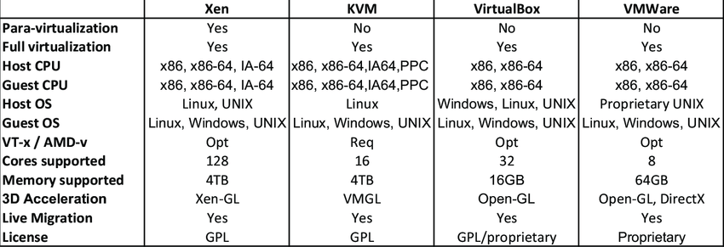

Fig 4: Comparison between Xen,KVM,VMWare

1. Advantage and limitation of virtualization

*Advantages of Virtualization:*

1. It is cheaper.

Because virtualization doesn’t require actual hardware components to be used or installed, IT infrastructures find it to be a cheaper system to implement. There is no longer a need to dedicate large areas of space and huge monetary investments to create an on-site resource. You just purchase the license or the access from a third-party provider and begin to work, just as if the hardware were installed locally.

2. It keeps costs predictable.

Because third-party providers typically provide virtualization options, individuals and corporations can have predictable costs for their information technology needs. For example: the cost of a Dell PowerEdge T330 Tower Server, at the time of writing, is $1,279 direct from the manufacturer. In comparison, services provided by Bluehost Web Hosting can be a slow as $2.95 per month.

3. It reduces the workload.

Most virtualization providers automatically update their hardware and software that will be utilized. Instead of sending people to do these updates locally, they are installed by the third-party provider. This allows local IT professionals to focus on other tasks and saves even more money for individuals or corporations.

*Disadvantages of Virtualization:*

1. It can have a high cost of implementation.

The cost for the average individual or business when virtualization is being considered will be quite low. For the providers of a virtualization environment, however, the implementation costs can be quite high. Hardware and software are required at some point and that means devices must either be developed, manufactured, or purchased for implementation.

2. It still has limitations.

Not every application or server is going to work within an environment of virtualization. That means an individual or corporation may require a hybrid system to function properly. This still saves time and money in the long run, but since not every vendor supports virtualization and some may stop supporting it after initially starting it, there is always a level of uncertainty when fully implementing this type of system

3. It creates a security risk.

Information is our modern currency. If you have it, you can make money. If you don’t have it, you’ll be ignored. Because data is crucial to the success of a business, it is targeted frequently. The average cost of a data security breach in 2017, according to a report published by the Ponemon Institute, was $3.62 million. For perspective: the chances of being struck by lightning are about 1 in a million. The chances of experiencing a data breach while using virtualization? 1 in 4.

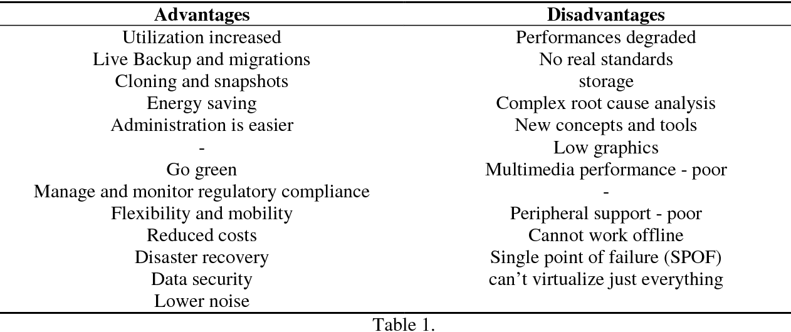

**Installation of Operating System on Virtual Machine:**

Explain steps to install OS on VM using KVM/Virtual Box with screenshots.

Step1: Download and install Virtual Box

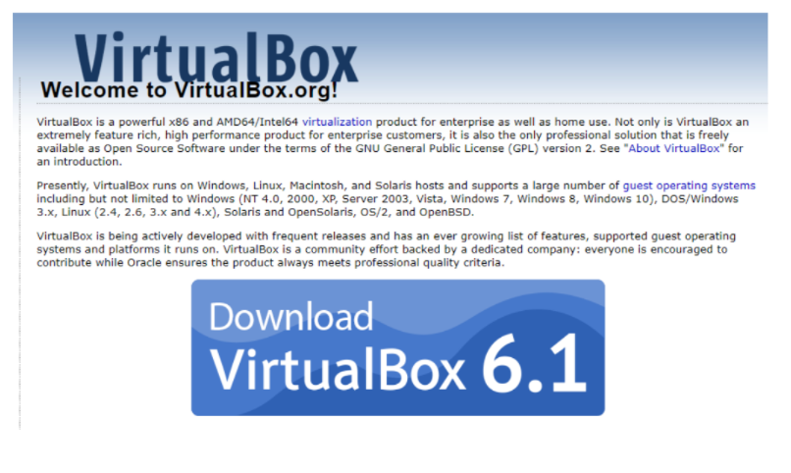

Step 2: Download the Linux ISO

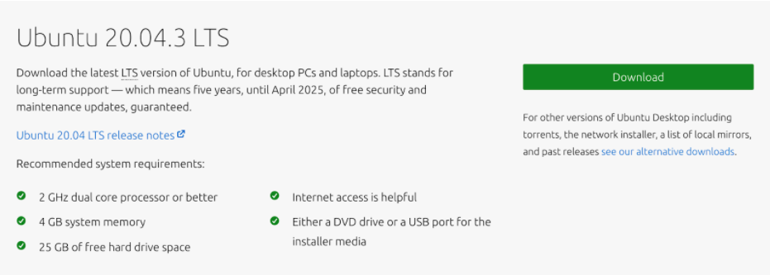

Step 3: Install Linux using VirtualBox

1. Start VirtualBox, and click on the New symbol.

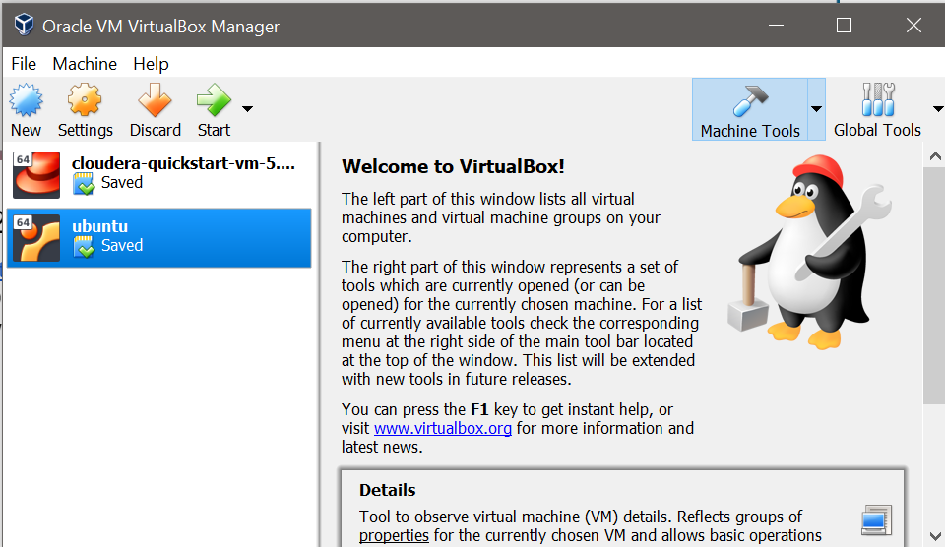

1. Give the virtual OS a relevant name.
2. Allocate RAM to the virtual OS.
3. Create a virtual disk. This serves as the hard disk of the virtual Linux system. It is where the virtual system will store its files. Click on the “Create” button.

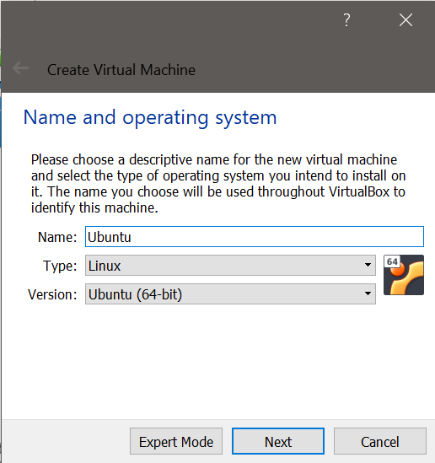

1. Choose VDI file type here. You can choose any other type of file that you would like to use.
2. Then click on “Next”.
3. You can choose either the “Dynamically allocated” or the “Fixed size” option for creating the virtual hard disk. The “Dynamically allocated” option will allow your Ubuntu operating system to expand the disk size if required.

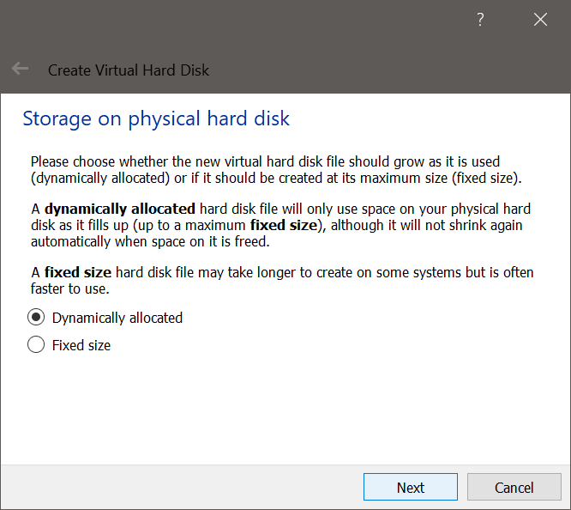

1. Choose the file location. This will be the location where your Ubuntu operating system files will be downloaded and installed on your Windows operating system.
2. Also, you can choose the virtual hard disk size from here. The recommended size is 10 GB. 15-20 GB is preferable.
3. Then click on the “Create” button.
4. Once you create this machine, you will be able to see the new machine here. Once everything is in place, it’s time to boot that ISO and install Linux as a virtual operating system.
5. Select the machine and click on the “Start” button.
6. If VirtualBox doesn’t detect the Linux ISO, browse to its location by clicking the folder icon as shown in the picture below:
7. Soon you’ll find yourself inside Linux. You should be presented with the option to install it.
8. Things from here are Ubuntu-specific.
9. Click on “Install Ubuntu”. On the left-hand side, you can choose the language in which you want to install Ubuntu.
10. In the next window, you will see the keyboard layout. You can skip to “Continue” or choose the keyboard layout that you wish to use.
11. You can skip to “Continue”
12. Select ‘Erase disk and install Ubuntu. It won’t delete anything on your Windows operating system. You are using the virtual disk space of 15-20GB that we created in the previous steps. It won’t impact the real operating system.

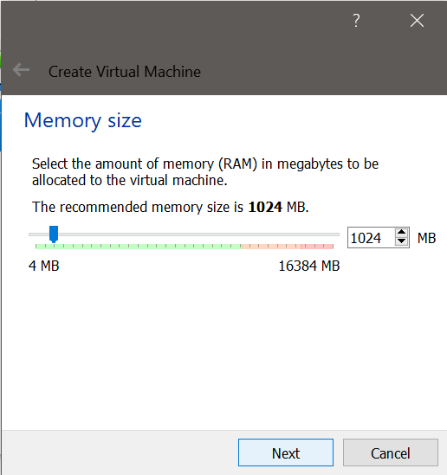

1. Then click on “Install Now”.
2. Just click on Continue.
3. Choose the location which is nearer to your physical location. Then click on the “Continue” button.

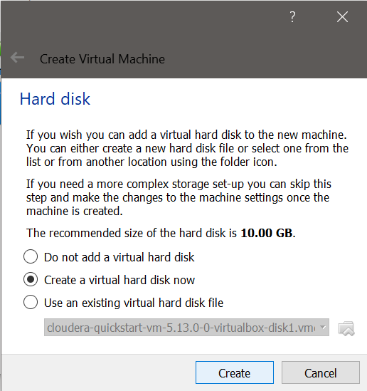

1. Give a name to your Ubuntu operating system. Choose a username. Try to choose a password that you can remember. You can also reset the password in Ubuntu if you forget it. Then click on the “Continue” button.
2. You are almost done. Now, the installation of Ubuntu will start on your Virtual Box. It may take 10-15 minutes to complete the installation.

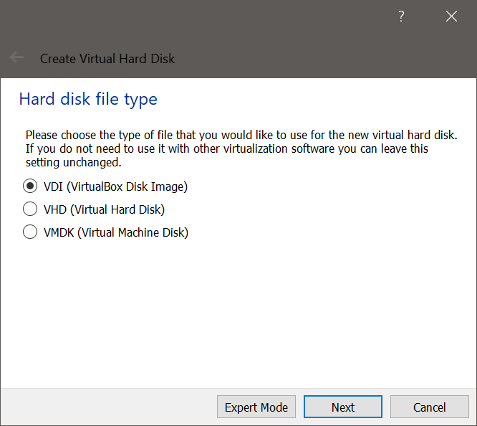

1. Once the installation finishes, restart the virtual system. Click on the “Restart Now” button.
2. Press Enter.
3. Here, you can see your username which you have given to your Ubuntu operating system.
4. Just click on this user.

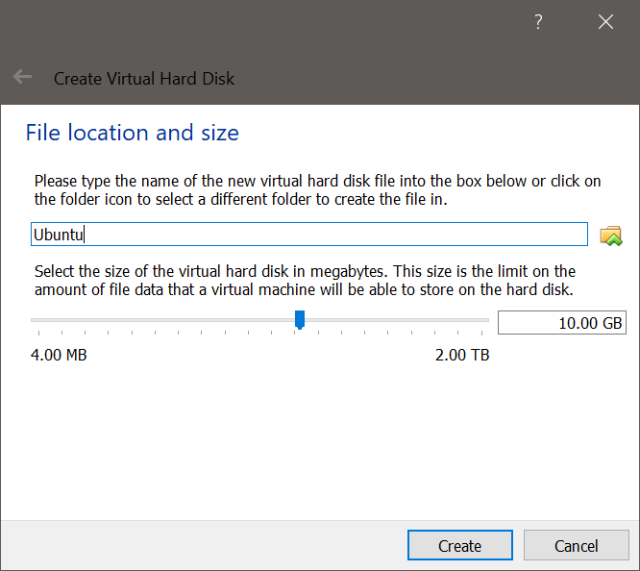

1. Here, you can see your username which you have given to your Ubuntu operating system.
2. Just click on this user.

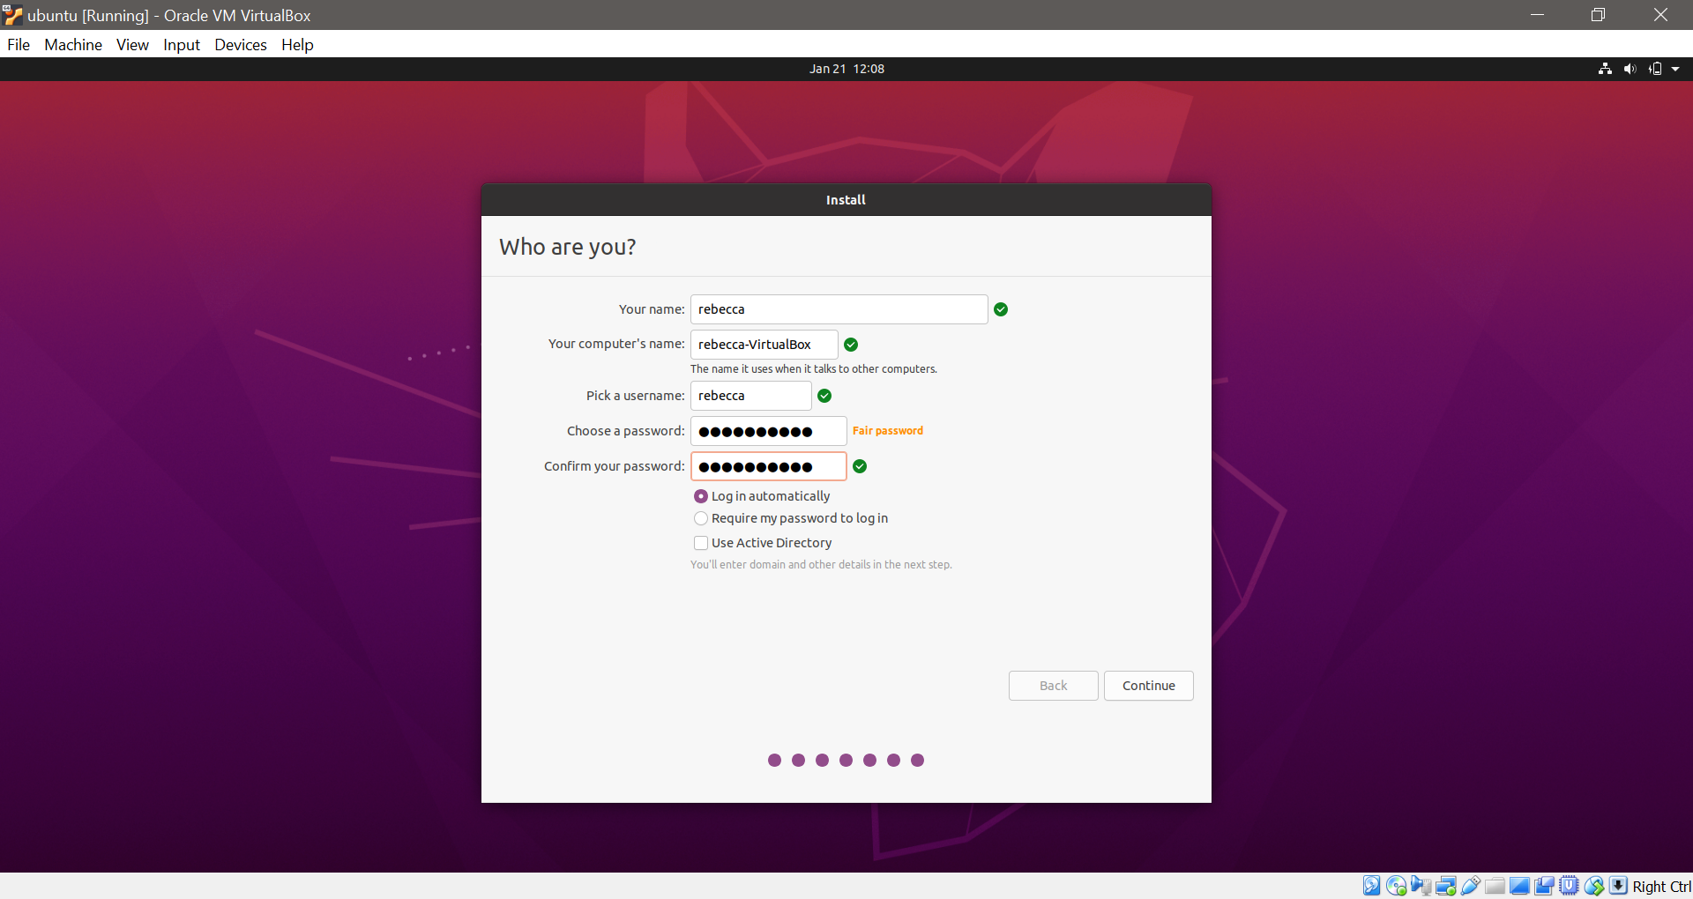

1. Enter the password which you have given at the time of installation. Then press Enter.
2. Now, you will be able to see the Ubuntu desktop here.
3. And that’s all folks. From now on, just click on the installed Linux virtual machine. You’ll be able to use it directly. The installation is a one-time-only process. You can even delete the Linux ISO that you downloaded earlier

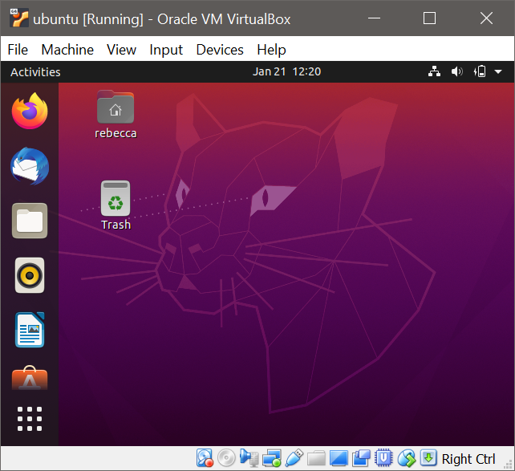

**Conclusion:**

Criteria to select specific type of Hypervisor

The following factors should be examined before choosing a suitable hypervisor:

* Virtual machine performance: Virtual systems should meet or exceed the performance of their physical counterparts, at least in relation to the applications within each server. Everything beyond meeting this benchmark is profit. Ideally, you want each hypervisor to optimize resources on the fly to maximize performance for each virtual machine. The question is how much you might be willing to pay for this optimization. The size or mission-criticality your project generally determines the value of this optimization.
* Memory management: Look for support for hardware-assisted memory virtualization. Memory overcommit and large page table support in the VM guest and hypervisor are preferred features; memory page sharing is an optional bonus feature you might want to consider.

How to resolve limitations of Virtualization.

Security primitives must be available on commodity computers with demonstrable assurance and understandable by ordinary users with minimum effort. Trusted computing bases comprising a hypervisor, which implements the reference monitor, and virtual machines whose layered operating system services are formally verified, will continue to fail these criteria for client-side commodity computers. We argue that demonstrable high assurance will continue to elude commodity computers, and complex policies that require management of multiple subjects, object types, and permissions will continue to be misunderstood and misused by most users. We also argue that high-assurance, usable commodity computers require only two security primitives: partitions for isolated code execution, and trustworthy communication between partitions and between users and partitions

**References:**

* [What is the Role of Virtualization in Cloud-based Services?](https://www.infopulse.com/blog/what-is-the-role-of-virtualization-in-cloud-based-services/#:~:text=Virtualization%20software%20allows%20multiple%20operating,Virtualization%20thus%20emulates%20hardware).
* [14 Advantages and Disadvantages of Virtualization – Vittana.org](https://vittana.org/14-advantages-and-disadvantages-of-virtualization)
* [7 Common Virtualization Challenges - And How to Overcome Them](http://blog.gdhconsulting.com/blog/7-common-virtualization-challenges-and-how-to-overcome-them)